Throwing Bingo
What you need:
- Homemade bingo cards
- Homemade “bingo balls” (letters)
- Objects to throw
- Targets
How to play:
- Create a bingo card/cards using capital and lowercase letters.
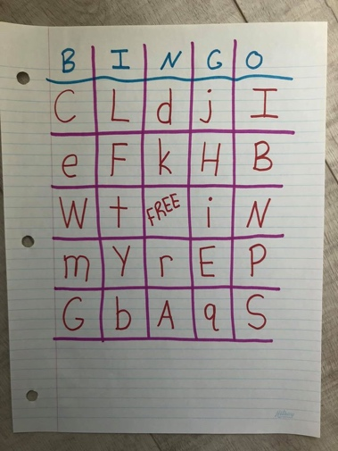
- Write the same letters that are on the bingo card on separate pieces of paper to make the “bingo balls” and spread them out, face up in the center of the playing area. If you have 3 bingo cards with the letter “A,” make sure you have 3 “A” in the center. You may also add extra “letters” for more of a challenge.
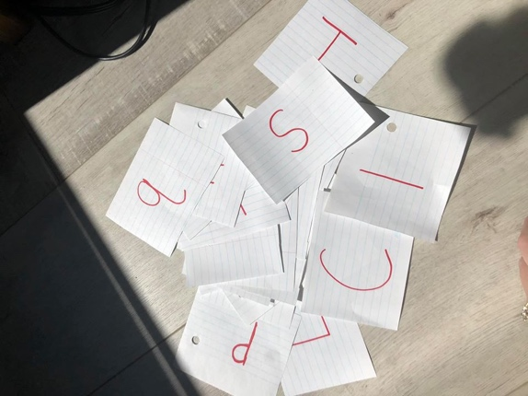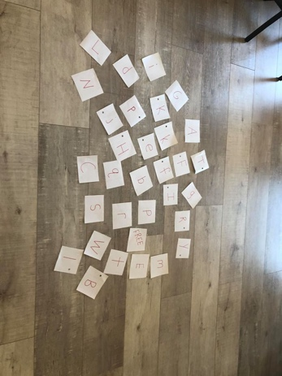
- Assign each child their “home base” with a bingo card, a throwing object, a target and their throwing line. When the game starts, the children throw their object at the target, once they hit their target they can run to the center and get a letter to place on their bingo card. If it’s a match they can keep it, if not run back and change it for another letter. Play continues until they have bingo (all matching letters).
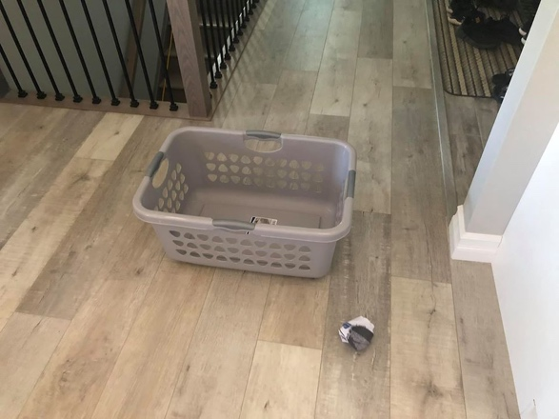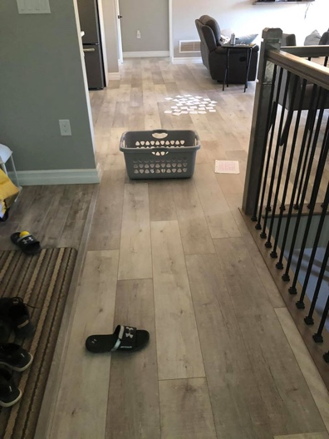
- In order for them to have bingo, their letters must be in the same order as their bingo card.
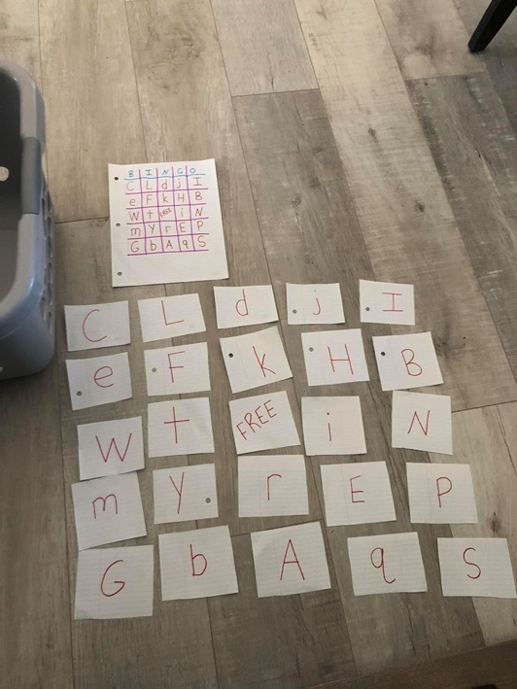

- If you only have one child playing, you could time them and see how long it takes them. Play at another time, and time then again.
- There are many adjustments you can make for this game.
  - Instead of letters you could use sight words, numbers, etc.
  - You can adjust the bingo card to be smaller or bigger.
  - Instead of throwing, have the children do a different task such as running in a circle before going to the center, hoping on one foot to the center and back, etc.

