Create Your Personal Workout Plan
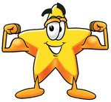
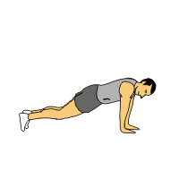
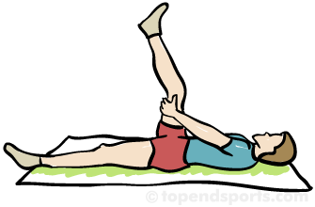

Muscular Strength
Muscular Endurance
Flexibility
Cardiovascular
Create a balanced Personal Workout Plan of 8 different exercises. For each exercise identify the following:
1. Name of the exercise; 2. How many times/how long for each exercise? 3. Draw a picture of the exercise 4. Circle which area of fitness it will improve?

1. | 2. | 3. | 4.
How many times?/How long for? | How many times?/How long for? | How many times?/How long for? | How many times?/How long for?
Diagram | Diagram | Diagram | Diagram
5. | 6. | 7. | 8.
How many times?/How long for? | How many times?/How long for? | How many times?/How long for? | How many times?/How long for?
Diagram | Diagram | Diagram | Diagram
Adapted from: iPhys-ed.com

